**BIG DATA LAB-08**

**5) Extract facts using Hive :**

1)Create and Drop Databases

2)Create, Alter , Drop Table

3)Built-in Operators

4)Built-in function

5)Views and Index

6)HIVEQL(select where , Select Order by, Select group by , Select Joins )

**>Performing basic Hadoop commands**

cd $HADOOP_HOME/sbin

./start-all.sh

jps

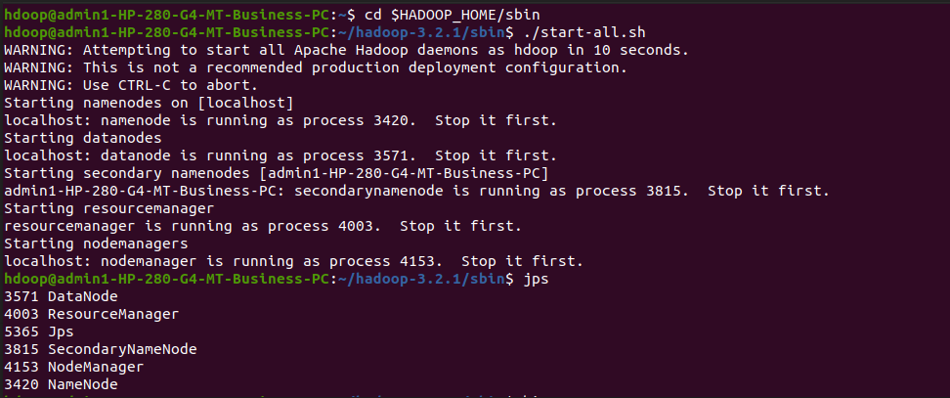

**>Performing basic hive commands**

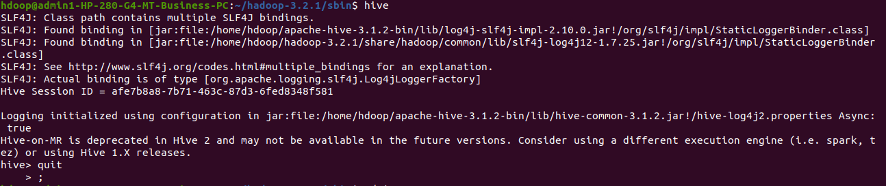

cd $HIVE_HOME

cd lib/

ls

rm –rf metastore_db/ //to remove metastore data

ls

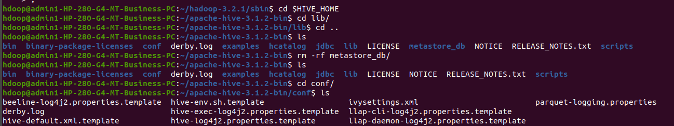

Schematool –initSchema –dbType derby

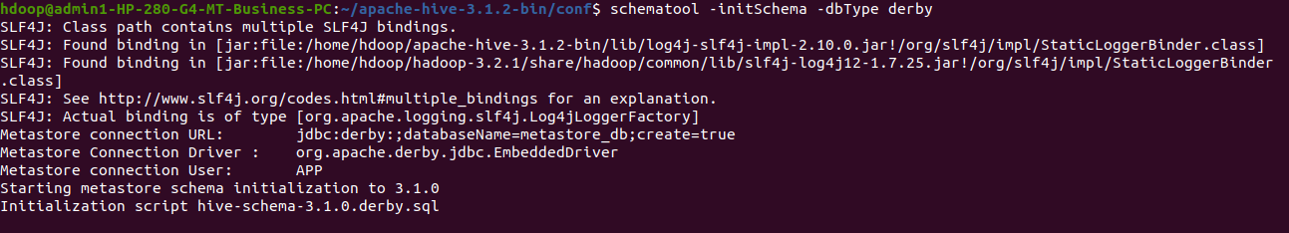

hive

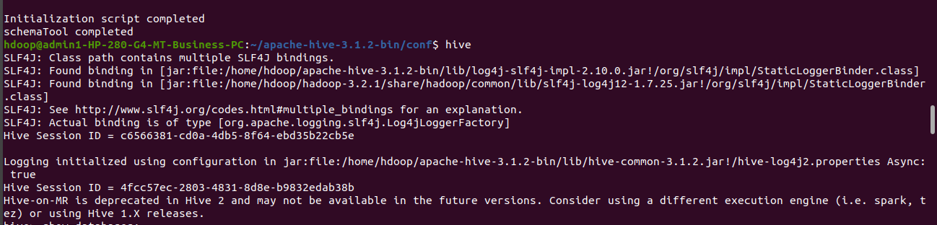

**>Creating a databases**

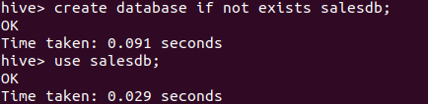

**>Creating a tables and displaying it**

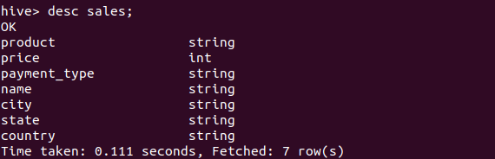

**>Inserting values into to the table**

insert into sales values('product200',5000,'Mastercard','Kumar','Astoria','California','USA');

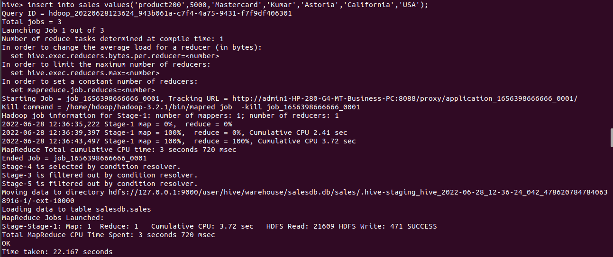

insert into sales values('product201',1000,'Visa','Kamal','Banglore','Karnataka','India');

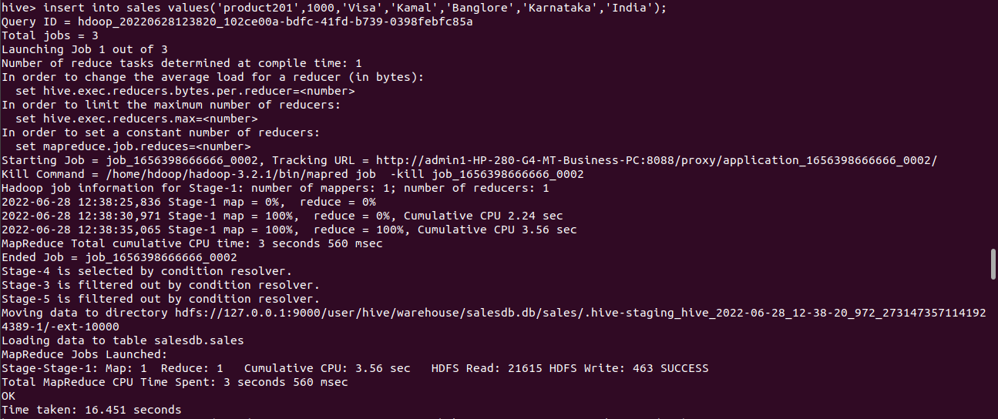

insert into sales values('product202',3000,'Diners','Koushik','Banglore','Karnataka','India');

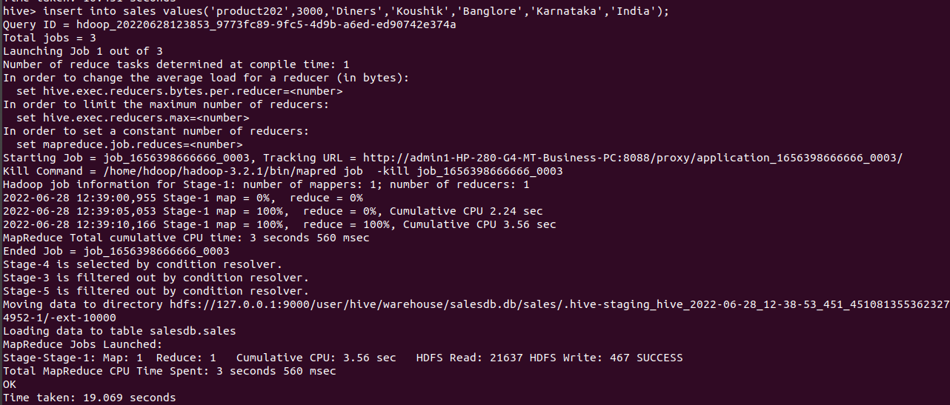

insert into sales values('product203',3000,'MasterCard','Harshini','Banglore','Karnataka','India');

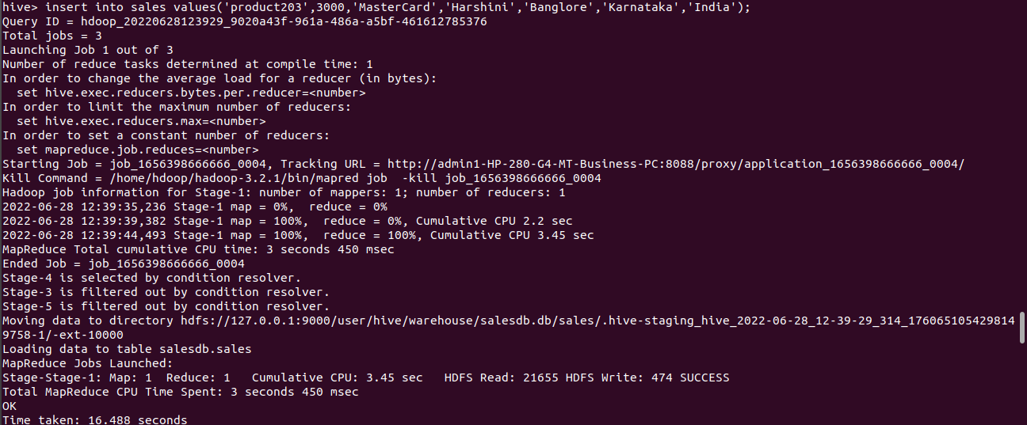

insert into sales values('product204',5000,'Visa','Snehitha','Chittor','AP','India');

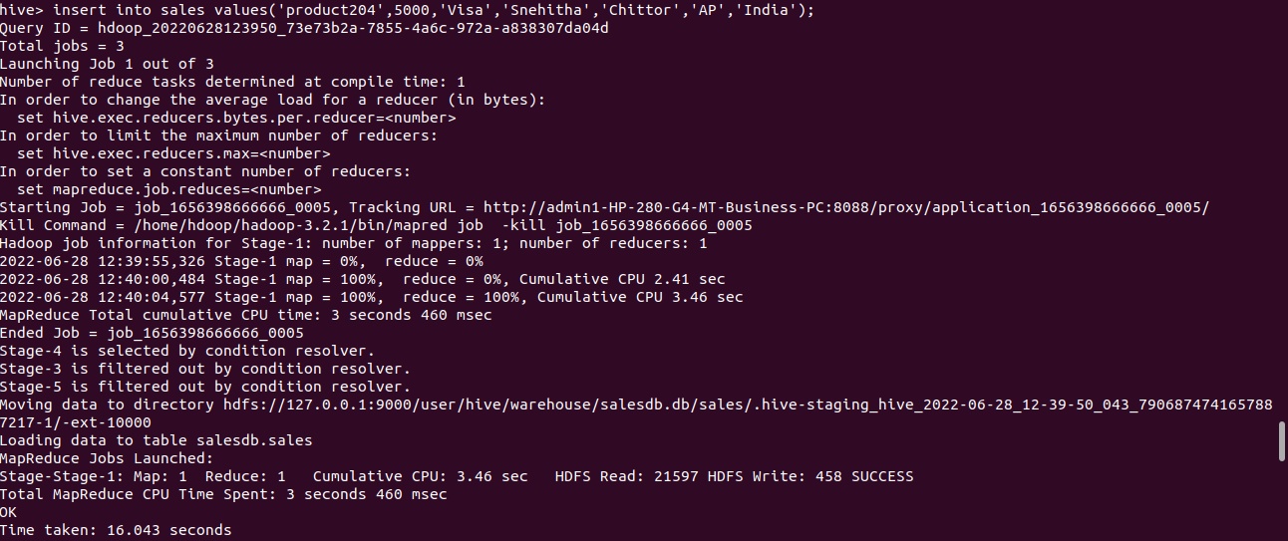

insert into sales values('product205',6000,'Rupay','Teja','ATP','AP','India');

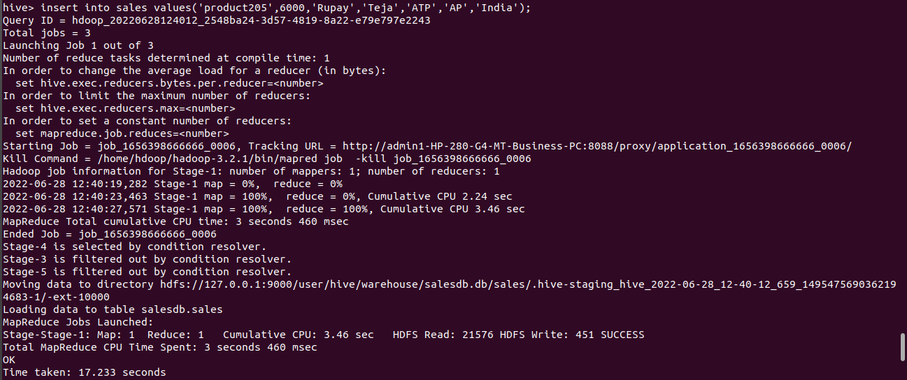

**Displaying all the inserted values**

select * from sales;

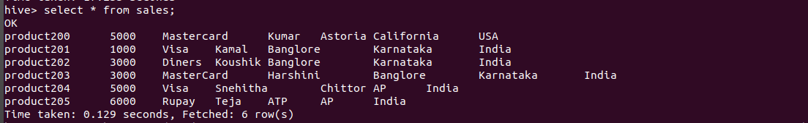

**Creating a new table and droping it**

create table Salet(Product string,Price int,Payment_type string,Name string,City string,State string,Country string)

drop table Salet;

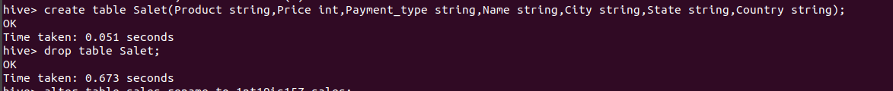

**Altering table**

alter table sales rename to 1nt19is157_sales;

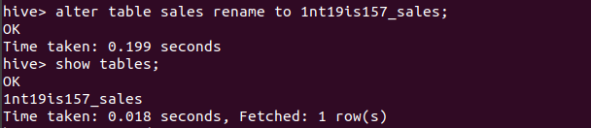

**>BUILD IN OPERATOR**

**Arthematic operator in hive**

select product,name,price+1500 from 1nt19is157_sales;

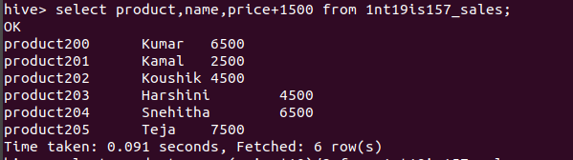

select product,name,(price*10)/2 from 1nt19is157_sales;

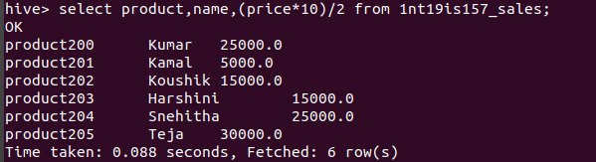

**Relational operator in hive**

select * from 1nt19is157_sales where price>4500;

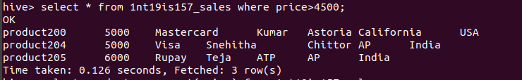

**>BUILT IN FUNCTION**

**Mathematical function in hive**

select product,name,sqrt(price) from 1nt19is157_sales;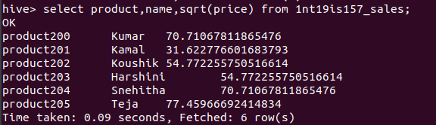

select product,name,floor(price) from 1nt19is157_sales;

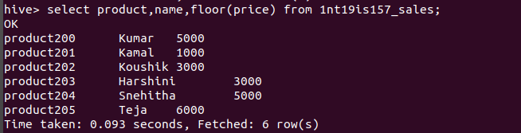

select product,name,cos(price) from 1nt19is157_sales;

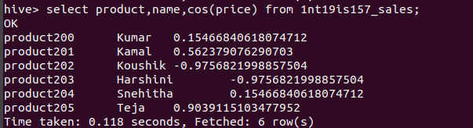

**Aggreagate Function in hive**

select max(price) from 1nt19is157_sales where state='Karnataka';

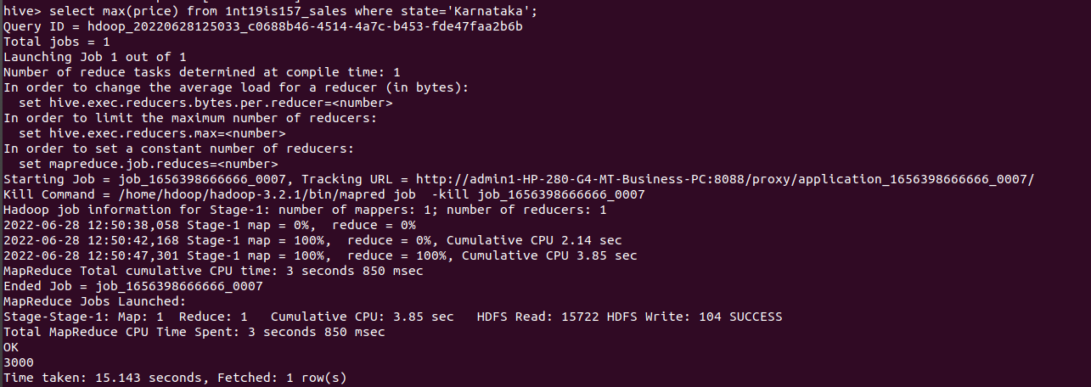

**Other built in function**

select product, upper(name) from 1nt19is157_sales;

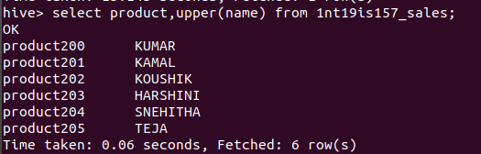

select product, reverse(name) from 1nt19is157_sales;

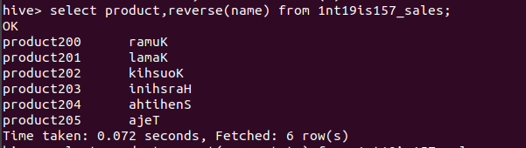

select product, concat(name,state) from 1nt19is157_sales;

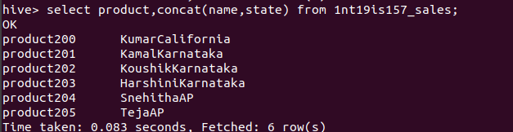

select product, trim(name) from 1nt19is157_sales;

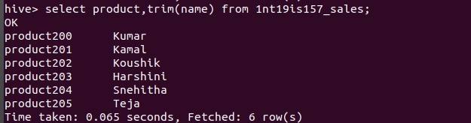

**>VIEWS**

create view visa as select * from 1nt19is157_sales where payment_type="Visa";

select * from visa;



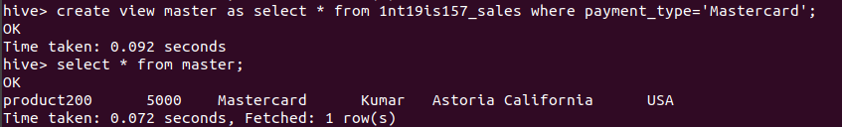

**>HIVEQL**

**Group by**

select count(*)as count,country from 1nt19is157_sales group by country;

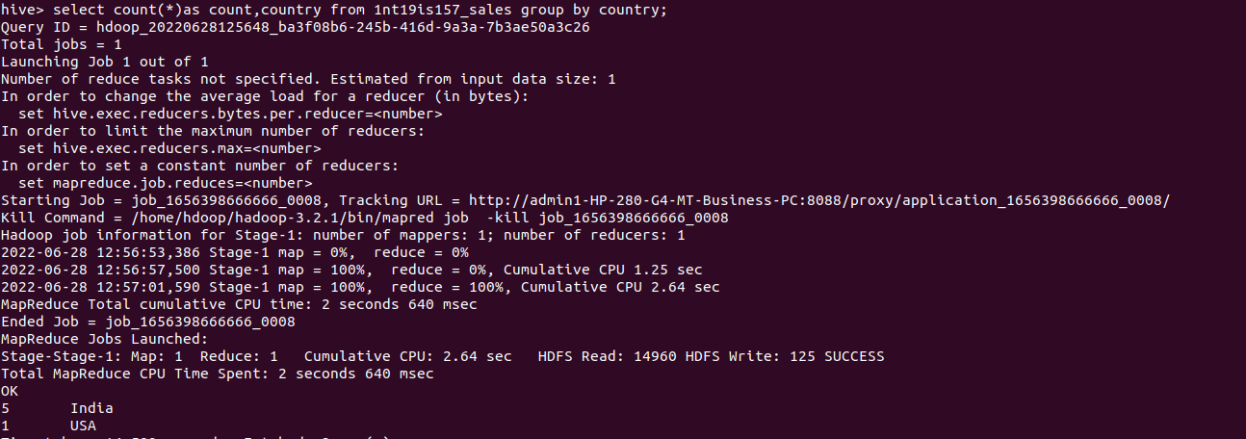

**Where**

Select * from sales where state=’karnataka’;



**Order by**

Select * from sales order by price;

